45617- Mobile Applications Development 3

Developer Diary
2D Platformer

Prepared by: Kieran O'Halloran
(G00326425)
Lecturer: Damien Costello
Stage: Year 4 Semester 7
Submission Date: 06th December 2018

Table Of Contents

Introduction……………………………………………………………………………………………… 1

Diary…………………………………………………………………………………………………………. 1

Test Plan..…………………………………………………………………………………………………. 6

Developer Discussion………………………………………………………………………………… 7

Introduction
This mobile application was created as part of my 4th year Mobile Application Development module in GMIT. This mobile application was designed by Gary Mannion, who is also a 4th year student. My job was to create and implement this design. It is a 2D side scrolling platform game which was to be made using the Unity engine with C# code. In this Developer Diary I will discuss how I went about making this application and the reasons why I altered some of the design decisions made by Gary.

Diary
27/09/2018
Today I received the design from Gary. I read through the design document and made a list of the tasks I would have to complete. These tasks included:
- Create a 2D platform game.
- Use Unity
- Create a player and enemies
- Make the player move and jump
- Make the enemies move along different parts of the platform
- Make the enemies kill the player if they run into them
- Kill player if they falloff the platform
- Give the player only three lives
- Collect tokens to earn points
- Create a scoring system
- Create a main menu
- Create a pause menu
- Create a score menu

14/10/2018
Today I started researching how I was going to achieve all of the tasks I had made. I used google to research different 2d platform games and took some ideas from these.

19/10/2018
Today I created an empty 2d Unity application. I added two folders to this project. One for sprites and one for scripts.

28/10/2018
Today I created a player sprite. I used a circle as my 2d player sprite as I was not given any specific sprites to use. I added a “PlayerController” script to this sprite to implement player movement and jumping. I used the WASD key controls to move the player and the spacebar for the player to jump as specified in the design document I received. I also added the main camera to this sprite so that the camera moves with the player and the player is always in the centre of the screen in gameplay.

09/11/2018
Today I added some platforms to the game and got the player moving along them. I added a box collider to these platforms so when the player makes contact with them, they would not fall through but instead sit on top of the platform and be able to move along them.

11/11/2018
Today I added another 2d sprite. I used a square as this sprite. The idea of this sprite was for it to act as an enemy and kill the player when they would collide. I also added a “KillPlayer” script to this sprite and a boxcollider 2d. I got this working and the player would now die when they ran into the square.

12/11/2018
Today I added checkpoints and respawning to the game. This allowed the player to come back to life after it had been killed by the square. I created a “CheckPointController” script and made a checkpoint prefab so I could use more than one checkpoint. I added a checkpoint to the start of the game and ont after the square. So if the player was killed by the square or before they got to the square the would restart the game ant the beging and if they were killed after they had passed the square they would restarte the game after the square.

14/11/2018
Today I encountered a problem with the player jumping. It would only hump once per play. To fix this problem I had to increase the “groundCheckRadius” in the “PlayerController” script.

17/11/2018
Today I added more platforms to make the game longer.

26/11/2018
Today I added a score system to the game. I added another 2d sprite. I used a diamond as this sprite. I added a “Token” script to the project and added it to the diamond sprite. I added a circlecollider2d to the sprite so when the player would collide with this sprite they would receive 100 points. I added a “Scoremanager” script that keeps track of the score and I can display it at the top right corner of the game.

27/11/2018
Today I added a border under the platforms so when the player falls of the platforms the would die and be respawned to the nearest checkpoint.

28/11/2018
Today I added a background image to the scene. I also laid out the scene as it was given to me in the design document by Gary. I am now displaying the player score during game play. I also created a new scene for the main menu.

01/12/2018
Today I created a second level to the game. I created a new scene and called it “level2”. I copied in “level1” to this scene and I altered it to make it more difficult for the player. I added more platforms and more enemies. I also added more tokens and made it harder for the player to collect them. I also increased the speed the player and enemies move at.

02/12/2018
Today I got the “MainMenu” fully implemented and working. I added a large rectangle at the end of each scene so that when the player is in contact with this sprite they can press the up arrow and this will move them to the next level.

03/12/2018
Today I added a pause menu to the game. When the player is in the middle of a game, they can press the esc button on their keyboard and the game will stop and they will be greeted with a pause menu. They will have two option, Continue and Return to main menu.

04/12/2018
Today I added a new scene “ScoreMenu” the player will be able to navigate to this menu from the “MainMenu” and it will display the last score recorded in the game. It will also have a button to return to the main menu so the user does not get stuck on this menu.
I also created a new script “LifeController” this will give the player 3 lives in each scene. If they use all of these 3 lives the game will be over and they will return to the main menu. The number of lives will also be displayed in the top right corner during game play.

05/12/2018
Today I added sound for when the player collects a token and a different sound for when the lpayer is killed.

Test Plan
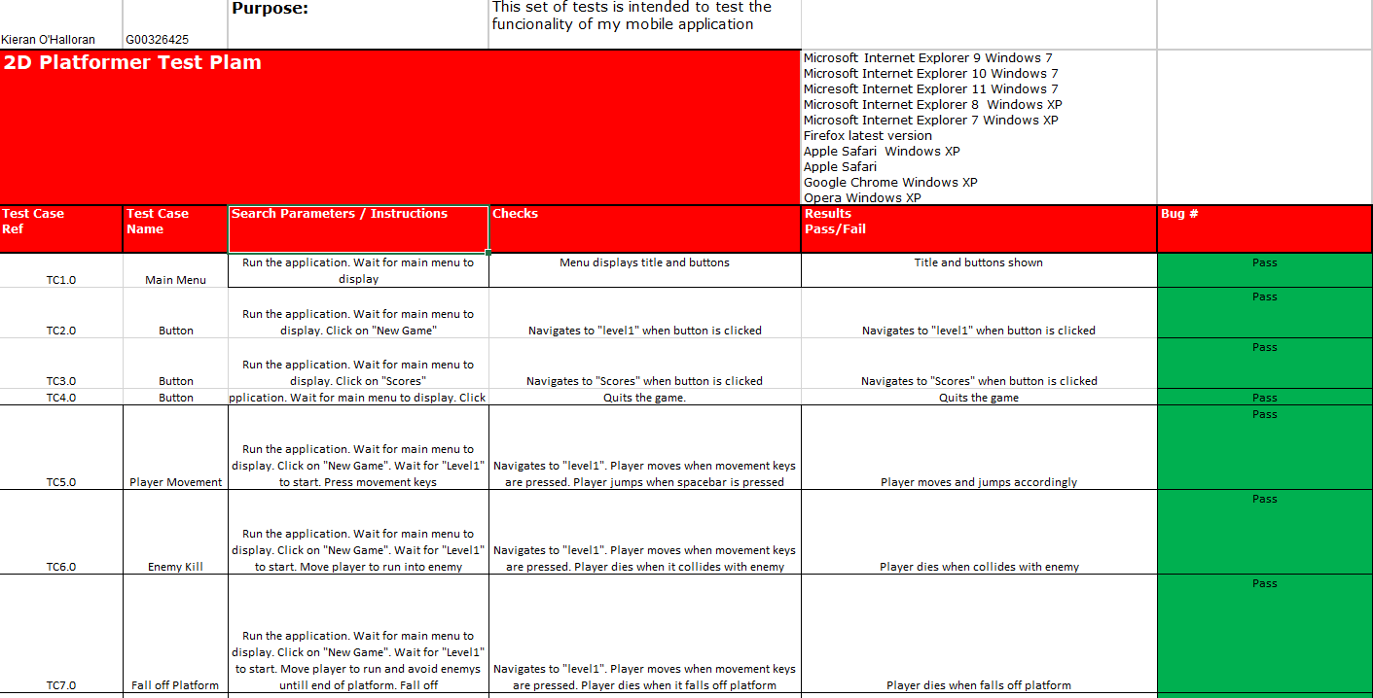
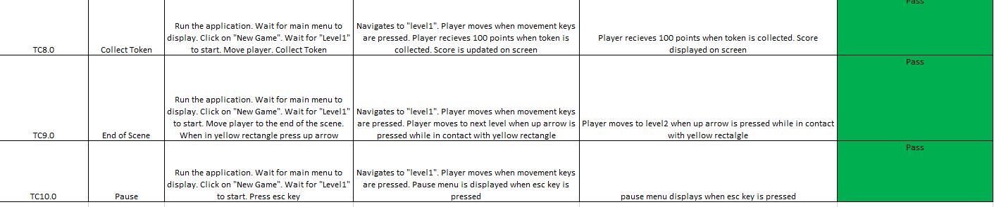

Developer and Customer Discussion
Though tout the Development of this project I was in communication with Gary on multiple occasions in person. I asked him questions that I was not sure about. He was very helpful and left a lot of the decisions up to myself, such as the sprites and background images that would used in the game. I decided to make a few small changes to the design. These include:
- Killing enemies- Gary had in his design document that the player would be able to kill the enemy by jumping on their head but I decided that the player would not be able to kill the enemies as it would make the game too easy. All the player would have to do would be kill the enemies and they would be free to go around and collect all the tokens at ease. I thought it would be better to leave the enemies there so it would be harder collect the tokens.
- Sound- Gary had not mentioned anything about sound effects for the game in his design document so I asked him and he was happy for me to add some sounds for a better player experience. I added sound effects for when a player dies and when they collect a token
- Score menu- In the design document that I received form Gary he had a menu where all the scores would be displayed but I felt this would become very long over time so I asked him would he mind if I just displayed the latest score and he was happy for me to do this.

